Question NO 1
#include <stdio.h>
#include <pthread.h>
#include <unistd.h>
void*factorial(void*arg){
int n=*((int*)arg);
int fact=1;
for(int i=1;i<=n;i++){
fact*=i;
}
int*result=&fact;
pthread_exit((void*)result);
}
int main(){
pthread_t threads[4];
int numbers[4]={4,5,6,7};
long long*result;
for (int i=0;i<4;i++){
pthread_create(&threads[i],NULL,factorial,(void*)&numbers[i]);
}
for (int i=0;i<4;i++){
pthread_join(threads[i],(void**)&result);
printf("Factorial of %d is %lld\n",numbers[i],*result);
}
return 0;
}
Output
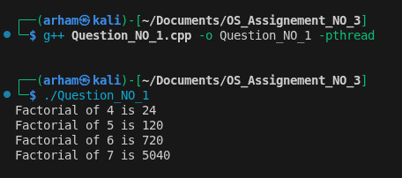

Question NO 2
#include <iostream>
#include <pthread.h>
#include <dirent.h>
#include <fstream>
#include <vector>
#include <string>
#include <cstring>
using namespace std;
#define CHUNK_SIZE 1024
struct ThreadData {
vector<string> files;
string searchStr;
};
bool searchInFile(const string& filename, const string& searchStr) {
ifstream file(filename);
if (!file)
return false;

char buffer[CHUNK_SIZE + 1];
string leftover = "";

while (file.read(buffer, CHUNK_SIZE) || file.gcount()) {
buffer[file.gcount()] = '\0';
string data = leftover + buffer;

if (data.find(searchStr) != string::npos)
return true;

if (data.length() >= searchStr.length())
leftover = data.substr(data.length() - searchStr.length());
else
leftover = data;
}

return false;
}
void* searchThread(void* arg) {
ThreadData* data = (ThreadData*)arg;

for (const string& file : data->files) {
if (searchInFile(file, data->searchStr)) {
cout << "String words Found in file: " << file << endl;
}
}

pthread_exit(NULL);
}

int main() {
string dirPath, searchStr;

cout << "Enter directory path: ";
getline(cin, dirPath);

cout << "Enter search string: ";
getline(cin, searchStr);

DIR* dir = opendir(dirPath.c_str());
if (!dir) {
cerr << "Unable to open directory\n";
return 1;
}

vector<string> allFiles;
struct dirent* entry;

while ((entry = readdir(dir)) != NULL) {
if (entry->d_type == DT_REG) {
allFiles.push_back(dirPath + "/" + entry->d_name);
}
}
closedir(dir);

ThreadData tdata[2];
tdata[0].searchStr = searchStr;
tdata[1].searchStr = searchStr;

for (size_t i = 0; i < allFiles.size(); i++) {
tdata[i % 2].files.push_back(allFiles[i]);
}
pthread_t t1, t2;

pthread_create(&t1, NULL, searchThread, &tdata[0]);
pthread_create(&t2, NULL, searchThread, &tdata[1]);

pthread_join(t1, NULL);
pthread_join(t2, NULL);
return 0;
}

Output
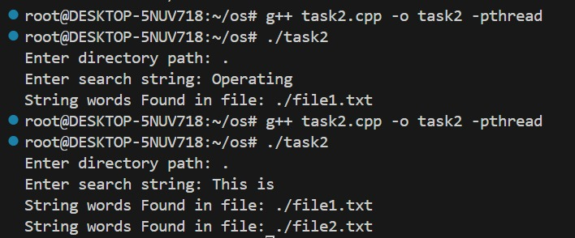
Question NO 3
DeadLock
#include <stdio.h>
#include <pthread.h>
#include <unistd.h>
pthread_mutex_t forks[5];
void* philosopher_deadlock(void* arg) {
int id = *(int*)arg;
int left = id;
int right = (id + 1) % 5;
printf("Philosopher %d is thinking\n", id);
sleep(1);

pthread_mutex_lock(&forks[left]);
printf("Philosopher %d picked left fork\n", id);

pthread_mutex_lock(&forks[right]);
printf("Philosopher %d picked right fork\n", id);

printf("Philosopher %d is eating\n", id);
pthread_mutex_unlock(&forks[left]);
pthread_mutex_unlock(&forks[right]);
return NULL;
}
int main() {
pthread_t p[5];
int id[5];

for (int i = 0; i < 5; i++)
pthread_mutex_init(&forks[i], NULL);
for (int i = 0; i < 5; i++) {
id[i] = i;
pthread_create(&p[i], NULL, philosopher_deadlock, &id[i]);
}
for (int i = 0; i < 5; i++)
pthread_join(p[i], NULL);
return 0;
}
Output
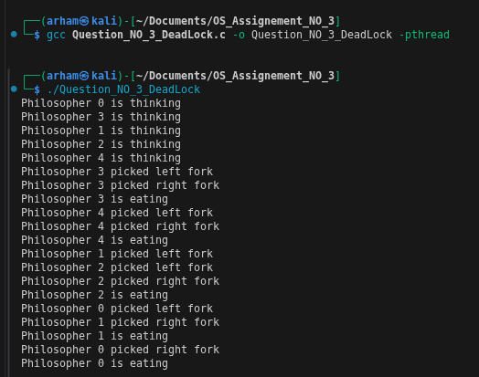

Solution
#include <stdio.h>
#include <pthread.h>
#include <unistd.h>

pthread_mutex_t forks[5];

void* philosopher_safe(void* arg) {
int id = *(int*)arg;
int left = id;
int right = (id + 1) % 5;

printf("Philosopher %d is thinking\n", id);
sleep(1);

if (id == 4) {
pthread_mutex_lock(&forks[right]);
pthread_mutex_lock(&forks[left]);
} else {
pthread_mutex_lock(&forks[left]);
pthread_mutex_lock(&forks[right]);
}

printf("Philosopher %d is eating\n", id);
sleep(1);

pthread_mutex_unlock(&forks[left]);
pthread_mutex_unlock(&forks[right]);

return NULL;
}
int main() {
pthread_t p[5];
int id[5];

for (int i = 0; i < 5; i++)
pthread_mutex_init(&forks[i], NULL);
for (int i = 0; i < 5; i++) {
id[i] = i;
pthread_create(&p[i], NULL, philosopher_safe, &id[i]);
}
for (int i = 0; i < 5; i++)
pthread_join(p[i], NULL);
return 0;
}
Output
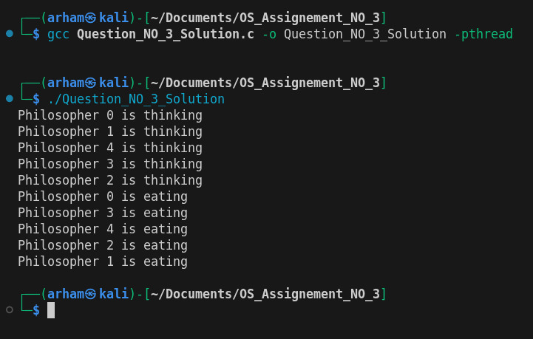
Question NO 4
#include <stdio.h>
#include <pthread.h>
#include <semaphore.h>
#include <unistd.h>

#define SIZE 3
#define TOTAL_ORDERS 5

int queue[SIZE];
int in = 0, out = 0;

sem_t empty, full, mutex;

void* restaurant(void* arg) {
for (int i = 1; i <= TOTAL_ORDERS; i++) {
sleep(2);
printf("Restaurant prepared order %d\n", i);

sem_wait(&empty);
sem_wait(&mutex);

queue[in] = i;
printf("Restaurant added order %d to queue\n", i);
in = (in + 1) % SIZE;

sem_post(&mutex);
sem_post(&full);
}
return NULL;
}

void* driver(void* arg) {
int id = *(int*)arg;
int order;

for (int i = 0; i < TOTAL_ORDERS / 2 + 1; i++) {
sem_wait(&full);
sem_wait(&mutex);

order = queue[out];
printf("Driver %d picked order %d\n", id, order);
out = (out + 1) % SIZE;

sem_post(&mutex);
sem_post(&empty);

sleep(1);
printf("Driver %d delivered order %d\n", id, order);
}
return NULL;
}

int main() {
pthread_t rest, d1, d2;
int id1 = 1, id2 = 2;

sem_init(&empty, 0, SIZE);
sem_init(&full, 0, 0);
sem_init(&mutex, 0, 1);

pthread_create(&rest, NULL, restaurant, NULL);
pthread_create(&d1, NULL, driver, &id1);
pthread_create(&d2, NULL, driver, &id2);

pthread_join(rest, NULL);
pthread_join(d1, NULL);
pthread_join(d2, NULL);

sem_destroy(&empty);
sem_destroy(&full);
sem_destroy(&mutex);
return 0;
}
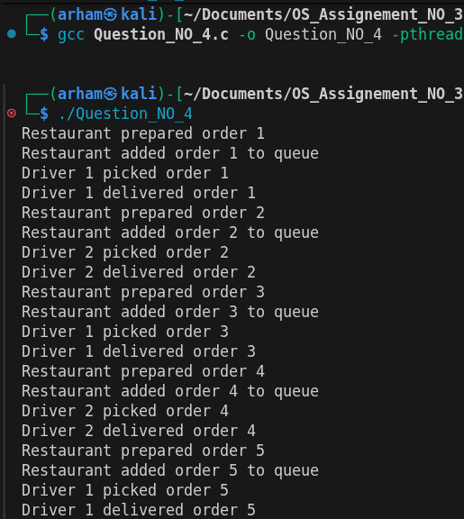
Output

